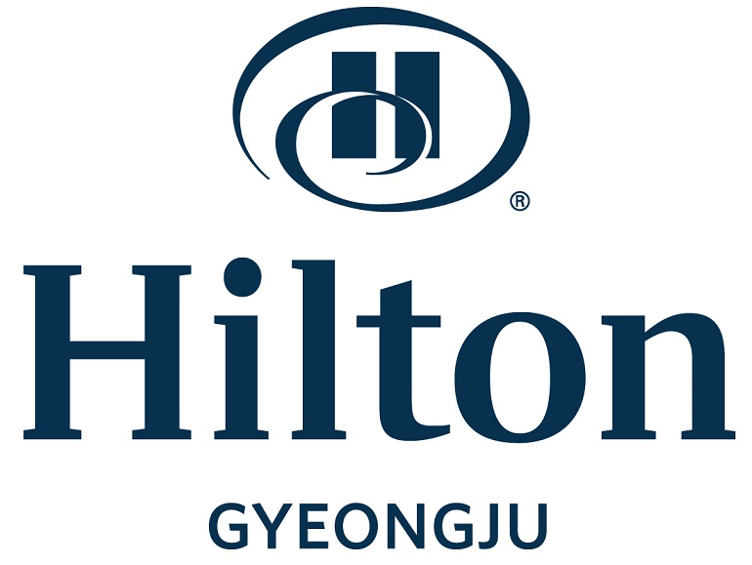
Hilton Gyeongju Hotel Reservation Form
(ICAPP 2023)

* Please complete this form with all requested information and send it to the hotel directly by e-mail or fax.
* Contact Point: Dong Hyo, Seo/Room Reservation Manager/E-mail: donghyo.seo@hilton.com
Fax: +82-54-745-7799 / Phone: +82-54-740-1232~4, +82-54-745-7788

Participant Information
First Name |  |  |  |  | Last Name |  |  |  |  |  | Title |  |  |  |  | Mr. Ms.
Company Name |  |  |  |  |  |  |  |  |  |  | Position
Sharing Room with First Name (Optional) |  |  |  |  |  |  |  |  |  |  |  | Last Name
Phone |  |  |  |  |  |  |  |  |  |  | E-mail
Arrival Date |  |  |  |  |  |  | Departure Date |  |  |  |  |  |  | No. of Nights
Special request and comments
Non-smoking: All Rooms (Not available Smoking room)

Accommodation Information
Date | Room Type | Rate | Remark
April 23(Sun)~27(Thu) | Single or Twin Room | KRW 250,000 | Breakfast 1 Person included
Breakfast Buffet |  | KRW 40,000Per Person | Lakeside (06:30~ 10:00)
* 10% service charge & 10% tax are included in the above rates.
* Free Wireless Internet for 24 hours
* Complimentary use of Gymnasium

Payment Information
In order to guarantee your reservation, your credit card information must be accompanied.
AMEX VISA Master Dinners JCB Other( )
Card No. |  |  |  | Expiration Date(mm/yy) |  | /
Cardholder’s Name |  |  | Date |  | Signature

Cancellation Policy
- If you wish to cancel, please do so 5 days prior to arrival to avoid cancellation penalties.
- Check-in time: 3 PM, Check-out time: 11:00 noon

Hotel Use Only
Confirmation No. |  | Reservation:

